2020 POA BOARD MEMBERS:  - President: Amanda Chambers  - Vice President: Loree Marroquin  - Treasurer: Heather Rollag  - Secretary: Molly Conn  OPPORTUNITIES TO SERVE:  - Special Events Chair  - Financial Audit and Oversite Committee  - Architectural Compliance Committee  We need volunteers in these areas, contact a board member or send your information and the area you are interested in serving to sweetbriarpoa@gmail.com. We welcome your input and fully encourage your participation.  It takes all of us to make our neighborhood something to be proud of!  Where do I find neighborhood information?  POA Board Information is located on the Sweet Briar Website. Meeting Minutes, Bylaws, Property Guidelines, Financial Reports and the latest updates: sweetbriarfishers.com  SB Residents Facebook site:  The FB site is not maintained by the Board. It is solely controlled by residents. Those who do not live in Sweet Briar are not granted access. Sweet Briar Neighborhood – Fishers, IN.  REMEMBER: | SPRING REMINDERS & NOTICES:  Community Park  What about the park’s trees?  The tree trimming and tree removal from the park were essential to maintaining a safe area. Arborist evaluated the trees, identified safety hazards and recommended an action plan. The trees were sick, damaged or hollow. They were removed to eliminate the storm safety risk.  Storm season resulted in the loss of several trees last year. The Board is working on a tree replacement program.  Help us keep the playground in top shape, we have experienced damage since the new repairs.  Leave the Park in better condition than you found it!  When taking a walk, don’t forget a baggie to pick up after your pet, no one likes pet waste in their yard or the park area. You are responsible for your fur baby. Be courteous to your neighbors and their children. The park is for everyone. Let’s keep it clean.  Take you cans, bottles and trash with you when you leave.  Trash cans should be removed from the street once emptied and stored out of street view.  Mailbox, Flood & Carriage Lights  Now is the time to evaluate the condition of your mailbox, flood and carriage lights. Email big projects to the POA for review. A well-lit neighborhood deters crime.  If You See Something,  Say Something! | PARKING:  When street parking, allow space for two vehicles to pass through. REMINDER: It is illegal to park directly across from a driveway. This could result in a fine from the FPD.  POOL NEWS:  The pool has been repaired and opened last week. Thank you Loree Marroquin for all your hard work in making this happen.  The Lifeguards are responsible for the pool area:  - They are following COVID guidelines. Be patient  - They should be treated with respect. Please remind our 14+ residents of this requirement.  COVD – 19 QUARANTINE:  Remain mindful of each other during this time of health crisis while enjoying the nice weather.  Always practice Social Distancing while outdoors. When active maintain a minimum of 6ft. A newly released Belgium research study indicated exercising caution of the active persons slip – stream. This is the air just behind the active person. COVID – 19 droplets can hover in the air exposing the person behind them.  Kids should take turns on the playground equipment. Change your clothes after the activity. Wash your hands thoroughly.  If you do not feel well, please stay indoors, wear a mask when outside.
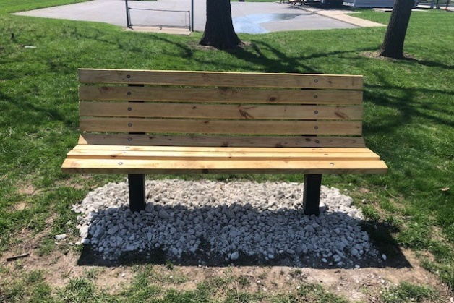
KINDNESS ALL AROUND
Your Neighbors Care!

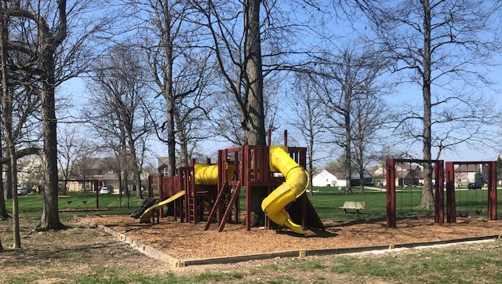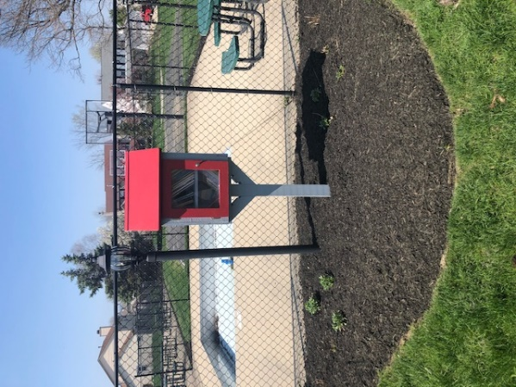
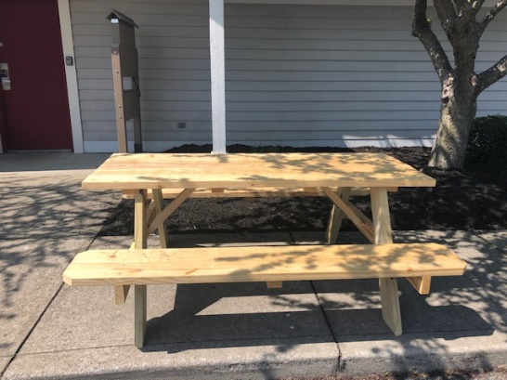
Kudos Too You!!
When you see these neighbors – say a big THANK YOU for the difference they have made!!
Darryl Taulbee, Gino Johnson & friends have rebuilt the playground frame, park benches and added two new picnic tables. Your effort and workmanship have not gone unnoticed. It looks amazing! What a difference you all made!!
Eagle Scout, Tom Chilson, installed a Sharing Library complete with improved landscaping. Awesome job! And congratulations on earning your Eagle Scout award.
The Blessing Box at the pool house door was a great idea! We’re not sure who started it; however, we appreciate your thoughtful kindness during this time! Everyone is welcome to make a donation.

